**Nonlinear Programming Problem 58:**

The costs of producing Microsoft Xbox Elite products: console, wireless controller, or combo (combo of console and controller) are $250, $100, and $350, respectively. Shown below are the sizes of the three market segments for these products and how much each of the segments is willing to pay for Xbox Elite products: console alone, wireless controller alone, or combo. Under the assumptions that a market segment will buy the product combination that yields the maximum nonnegative surplus (value minus cost), and a segment will buy no product if no product has a nonnegative surplus, determine an optimal set of product prices. Should the company offer all products for sale?

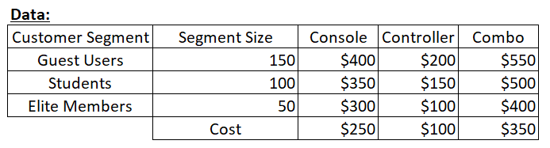

**Discussion:**

This is a nonlinear programming problem. From the information given, we need to decide which Microsoft products we should release into the market and how much should we price these products. This depends on understanding which market segment will buy which product, which will be one of the decision variables. The price of the product is the second decision variable.

Also note that the model is only optimizing the selling price for the product that is being bought by the segments i.e. only for the products that are pushed into the market. We must set a selling price for these products so that the profit is maximized, which is our objective.

Here, we are assuming that a single segment can only buy one product, which is one of our constraints. The product being bought depends on which product is viewed by the segment as most valuable based on its cost. That is, the product that a segment buys must have the highest value (surplus) compared to the other products. Another notable constraint is that a segment does not buy any product whose surplus value is less than zero.